Rules

Purpose

The purpose of this project is to provide students with a practical transportation engineering problem. This challenge requires students to apply methods of intersection design, geometric design, pavement design, and traffic engineering along with the application of surveying and drafting techniques.

Problem Statement

Markham Malls is building a mega mall in the Reno area and has requested the conceptual designs and plans from several consulting firms. Each consulting firm is to design the most efficient and cost effective signalized intersection for the mall’s main entrance. The design must include pedestrian and bicycle facilities, striping, signage, pavement cross sections, standard details, and signal timing.

Requirements

All participants must follow the guidelines and requirements of this project in order to be considered for the contract.

Specifications

Existing topography and right-of-way limits are provided in the Civil 3D CAD file, “Mega_Mall_topo.dwg” . This drawing should be referenced in your plans (do not make any changes to the existing surface or right-of-way limits).

Posted Speed Limit 35 mph

Expected Design Level-of-Service C

Traffic Growth 2% Annually

Design Life 20 years

2016 Projected Traffic Volumes:

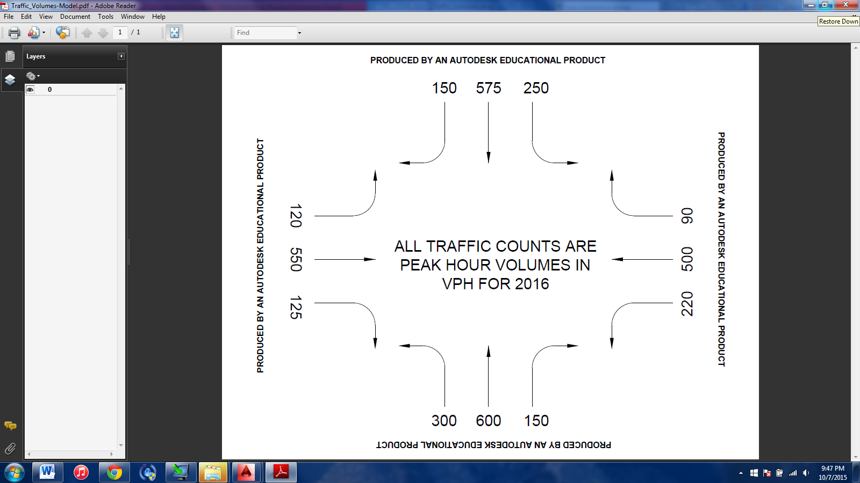

Submittals

The 100% plan documents, written summary, calculations, and opinion of probable cost should be combined into one .pdf and submitted by **March 13, 2016** **at 5:00 pm PST**  to [transpo.midpac2016@gmail.com](mailto:transpo.midpac2016@gmail.com) and include the following:

* Site Plan of the proposed intersection
* Roadway profiles
* Cut and Fill / Grading plan
* Signal timing and phasing Figure
* Detail sheet(s) including cross sectional details and standard construction details.
* Opinion of Probable Cost
* Calculations
* Written summary

All figures and plans must be computer drafted in the format of ANSI B (11”x17”).

All request for Information (RFI) should be sent to [transp.midpac2016@gmail.com](mailto:transp.midpac2016@gmail.com) prior to February 1, 2016.

Site Plan

The site plan should show the designed intersection with roadways extending at least 100’ from the stop bar in each direction (North, South, East, and West). Two centerlines (North-South direction and East-West direction) should be derived. All medians, turn pockets, sign locations, striping, and bike and pedestrian facilities should be clearly displayed. Additionally, any necessary detail callouts and dimensions should be shown on the plan(s). The Site Plan may be split up into multiple sheets with appropriate matchline callouts. Displaying landscaping features are optional.

Roadway Profiles

The profile plan should show two profiles, one for the north-south roadway alignment and one for the east-west roadway alignment of the designed intersection. The profile views should clearly display the existing ground and the designed finished grade profile. Grades, grade breaks, points of vertical intersection, and vertical curve dimensions should be clearly labeled on the finished grade profile lines.

Grading Plan

The grading plan should clearly display existing and finished grade contours. The design should aim for a near balance of cut and fill and the locations of each should be clearly defined. Also, be sure to provide sufficient elevation points at areas that are not covered by a specific detail.

Signal Timing and Phasing

The signal timing and phasing figure should clearly display the appropriate movements for each phase, the time for each phase, and total cycle length. Any formulas and assumptions should be clearly shown.

Detail Sheet(s)

Standard detail drawings should be combined onto the appropriate number of sheets. The details should be thorough enough to ensure that the contractor can correctly construct the designed intersection and roadways. A list of standard City of Reno details can be found at: <http://www.reno.gov/government/government/departments/public-works/forms-publications/construction-standard-details>. Any other details must be designed by the consulting firm and comply with any ADA standards as necessary. Additionally, roadway cross sections should be designed and displayed in this area. Be sure to make the appropriate call outs on the site plan that refers to the details using an organized detail numbering system (Example: See detail 3 on sheet DT-01)

Opinion of Probable Cost

A construction cost estimate for the project should be established via an excel spreadsheet. All variables associated with the construction of the new intersection should be considered with an assumed cost (in USD).

Calculations

The calculations sheet should be organized and clearly labeled with a title and numbered steps for each formula. All appropriate calculations should be conducted for the intersection to ensure a sufficiently designed intersection. The level of service calculation should be clearly displayed and should be appropriately backed up by a transportation engineering computer software calculation. Any assumptions should be clearly noted. The intersection must obtain a level minimum of a level C by the end of the 20 year design life.

Written Summary

The written summary should be no greater than 8 pages, double spaced, using 12 point Times New Roman font. The citations, cover page, table of contents, and appendices are NOT INCLUDED in the 8-page length.

The summary should review the entire project and also explain the following:

* Functionality of the intersection
* Efficiencies and benefits to the overall design
* Explanation of the chosen signal timing and phasing sequence
* Explain any innovative features of the intersection
* Discuss the traffic and pedestrian safety aspects of the design

Poster Session

All participating schools should prepare a poster that outlines the design around a final conceptual drawing of the intersection. Each poster must display (at the minimum) the school name, each participating member’s name, roadway cross section(s), phasing and signal timing diagram, and total cost estimate. The posters will be displayed on April 8, 2016. Please provide your own poster stand. Additionally, judges may ask questions for clarifications about the design at this time and will count towards the final poster scoring.

Judging

The judging criteria are as follows:

Site Plan 15

Roadway profiles 10

Cut and Fill/ Grading plan 5

Figure displaying Site triangles 5

Figure displaying signal timing and phases 10

Detail sheet(s) 10

Opinion of Probable Cost 10

Level of Service calculations 5

Written summary 15

Poster 10

Overall Formatting/Completeness 5

Total Points 100

All calculations and assumptions should be in reference with the most recent MUTCD, AASHTO and HDM.